Department | FED
Subject | DSA-2
Academic Year | I-III Semester(2025-26)
Faculty Name | BALAIAH SIR
Student Name | V.CHARISHMA
Roll Number | 2520030140
Branch | CSE
Course Outcome | 5

Case Study Topic: Snapdeal Product Catalog Optimization using Timsort on Partially Sorted Data
Work Done Summary:
- Analyzed Snapdeal's product catalog sorting problem.
- Identified natural runs in partially sorted product data.
- Reversed descending runs to create ascending runs.
- Applied Timsort run-detection strategy.
- Performed stable merging of runs.
- Compared Timsort with Merge Sort, Quick Sort, and Heap Sort.
- Studied galloping mode optimization.
- Evaluated performance on real-world e-commerce datasets.
Implementation Details:
- Collected the product catalog data:
[3, 7, 11, 5, 4, 6, 9, 12, 1, 2, 8, 10, 13, 14]
- Applied Timsort run-detection to identify natural runs.
- Detected ascending run:
[3, 7, 11]
- Detected descending run:
[5, 4]
- Reversed the descending run to obtain:
[4, 5]
- Detected another ascending run:
[6, 9, 12]
- Detected the final ascending run:
[1, 2, 8, 10, 13, 14]
- Applied stable merge operations between the detected runs.
- Merged all runs to generate a fully sorted catalog.
- Verified that Timsort efficiently handles partially sorted product data and maintains stability
Result: Screenshots / Output
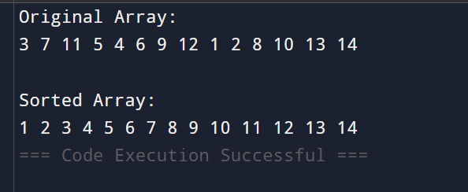
The Timsort algorithm successfully identified natural runs, reversed descending segments, and merged all runs to produce the sorted product catalog

Time Complexity : Timsort:
- Best Case: O(n)
- Average Case: O(n log n)
- Worst Case: O(n log n)

GitHub Link: https://github.com/virodulacharishma0506-del/DSA--2-Project/blob/main/Timesort.java
Student Signature | Faculty Signature

